**Exercise No:2**

**Date:14-10-2020**

**Aim:**

**To print the occurrence of x in the given list.**

**Program:**

**def count(lst, x):**

**count = 0**

**for ele in lst:**

**if ele == x :**

**count = count+1**

**print(count)**

**lst = []**

**n = int(input())**

**for i in range (0,n):**

**ele = int(input())**

**lst.append (ele)**

**x = int(input())**

**count (lst, x)**

**Link:**

[**http://103.53.53.18/mod/vpl/forms/edit.php?id=230&userid=1684#**](http://103.53.53.18/mod/vpl/forms/edit.php?id=230&userid=1684#)

**Output:**

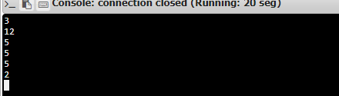

**Result:**

**Thus, the occurrence of x in the given list is printed successfully using python.**